Mission: Partnering with staff, students, and their families to create a safe, healthy, and inclusive learning environment that provides an enjoyable and positive experience for the entire school community.
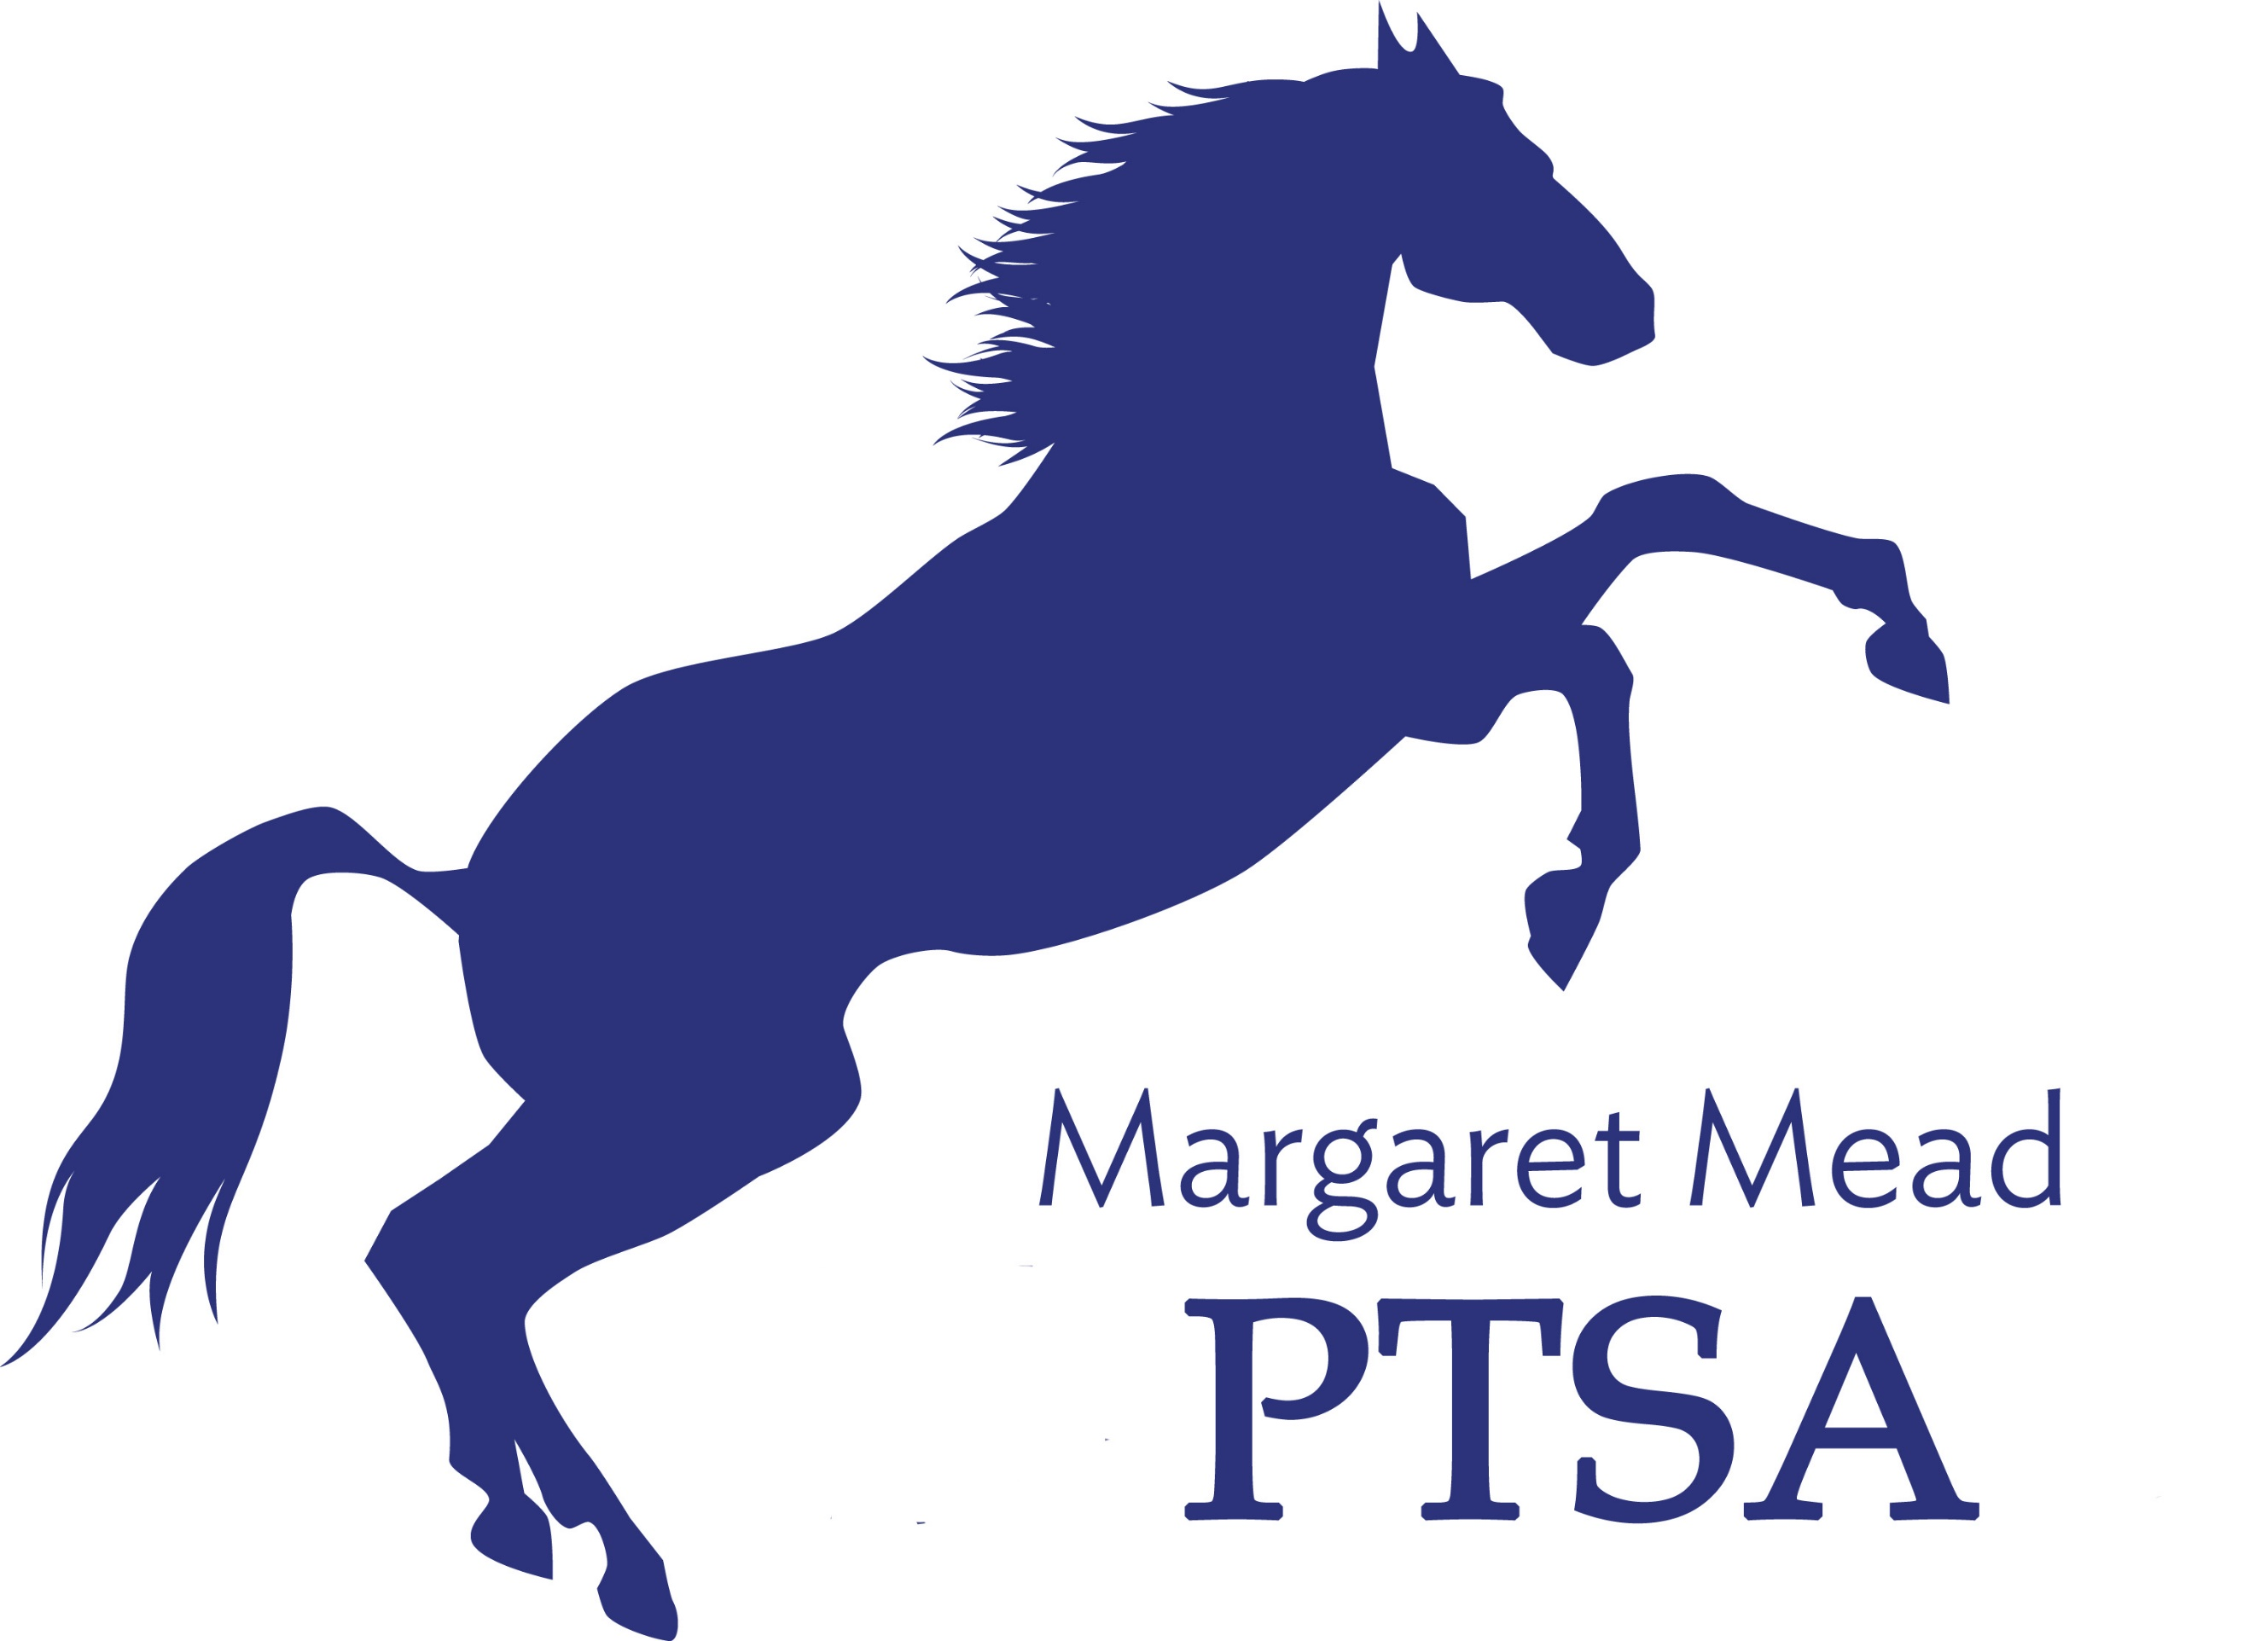
Margaret Mead Elementary PTSA
1725 216th AVE NE, Sammamish, WA 98074
PTSA Unit 2.8.38
www.meadptsa.org
Goal: Support the mission statement using
effective communication, connecting community, financial support & fiscal responsibility.
Board of Directors Meeting MINUTES February 4, 2021
Sharon Mason, Leta Hamilton, Ryika Hooshangi, Sue Gabica, Molly Hylen, Sarah Jensen, Ashley Arrington, Sandy Klein, Suzi Khendry, Antoinette Haynes, Trista Lofti, Charles Jamieson, Daniella Toledo, Heather Gibbons, Abi Nubla King, Cassy Patterson, Sharon Wu, Liz Moore, Catherine Tian, Niko Olsen
- Call to Order – 7:30pm
- January Minutes moved into record
- President Report:
- Word on the street – Rumors are circulating about which teachers are coming back to the school & which ones are not. Monday at 4pm Kindergarten & First Grade families will receive news about who their teacher is. Negotiations are taking place with 2-5 teachers. The goal is to get grades 2-5 back in March.
- Yearbook – previous yearbook volunteer decided it was going to be too much work, so she has dropped out. Ryika & Abi are hoping that a new volunteer or two will step forward. Ashwini is also helping to look for a new volunteer.
- Blackwell event 2/18? – Blackwell PTSA reached out & asked if we want to do an event with them. Birds + Bees + Kids is doing an event for Blackwell Elementary on Feb 18. They asked if we wanted to piggyback off their event. It would require Mead to pay $650. Board voted & majority approved/were in favor of partnering with Blackwell for this event. Ashley Arrington motioned to move $650 from savings to the Parent Education line item. Cassy Patterson seconded. Motion passed.
- Community building events
  - “How to…” series February 26th is next How To…
  - International Night—date change to March 5th. Fridays seem to be better for virtual events.
  - Bingo Night success – Shout out to Abi Nubla King for hosting Bingo Night. Thank you, Abi. The event was fun for all participants.
Secretary: Nominating Committee is working to codify the slate for 2021-2022 school year.
Treasurer:
- Treasurer’s Report – Mid Year Audit taking place now. Ending Balance $102,134.85
- Grant request for items to support socially distant recess. The recess supervising team acknowledges that recess will look very different during COVID-19. The team is asking for cones & other items that will help make recess fun while also making it clear where they can play. Grant was approved by the board for $1750.
- 3 New Teachers hired for K-1 return to in person learning. They are brand new teachers, which means they will qualify for $500 stipend for classroom supplies.

- Committee Reports
FACE: Liz Moore suggested asking Mead students to do FlipGrids for International Night. We asked Sandy Klein if there was something we could do for incoming kindergarten or first grade students to welcome them to Mead on Feb 18. PTSA board agreed to pay a company to put up welcome signage outside the school.
Membership: 268 members
Fundraising: Read-A-Thon is in April, the week after Spring Break.
Communications: Nothing to report.
Sustainability: Nothing to report.
Emergency Prep: Eprep district meeting was this week. Most eprep needs are being met by the district. We have money in our budget to buy hand sanitizer or hand sanitizer stations. Sandy Klein will get back to us if the school needs this. Council is putting together virtual community E-Prep events. Cassy will send dates to Sandy Klein.
- Principal/Staff Update: Mrs. Egeberg got married. Mrs. Ward Kinder teacher had a baby. Meghan Anothen is expecting a baby in March. Jenny Schafer got engaged. Staff is working extremely hard to bring quality education to our children. Mead is at an advantage when it comes to ventilation because we are a new school. Mead is split roughly 50/50 between remote & in person.

- Adjourn 8:35 - Next Board Meeting is MARCH 11, 2021 at 7:00pm
Upcoming Events:
- February 26 next “How To…”
- March 5: International Night
- March 11: Board Meeting
- April 15: Board Meeting
- April 29: Virtual Cooking Class

